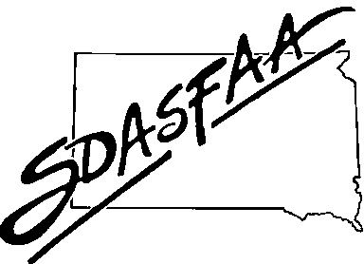**SDASFAA ANNUAL BUSINESS MEETING AGENDA**

Wednesday, April 30, 2025 – 12:00 PM Central Time

***2025 Executive Council Members***

Tracey Buisker (SDSU) President

Tirzah Knight (BHSU) President-Elect

Sydney Chapman (SDSU) Past President

Kim Nida (SDSMT) Secretary

Morgan Stadler (NSU) Treasurer

Stephen Detlefs (BHSU) Members at Large through 2025

Mary Alexandar (DWU) and Mindy Haerer (NAU) Members at Large through 2026

Sara Edwards (Citizen Bank) Associate Member at Large

***2025 Committee Chairs***

Training Committee Cathy Mueller, Mapping Your Future Membership & Records Committee Tirzah Knight (BHSU)

2026 Spring Conference Committee Tracey Buisker (SDSU) Communications & Website Committee Kim Nida (SDSMT)

Recognition Committee Sydney Chapman (SDSU) Review Committee Sara Edwards (Citizen Bank)

1. **Call Meeting to Order -** 12:10pm quorum – yes
2. **Approval of Agenda –** Motion by Becky, second by Micah – no changes – all aye
3. **Approval of April 17, 2024, Annual Business Meeting Minutes** no corrections – approved as is
4. **Officer Reports** – Motion by Melinda, second by Mary – no discussion – all aye – motion carried

a. Past President Sydney Chapman

1. President-Elect Tirzah Knight
2. President Tracey Buisker
3. Treasurer Morgan Stadler
4. **Old Business - 2024 Committee Reports**
   1. Training Committee Becky Pribyl
   2. Recognition Committee Kristy O’Kief
   3. Communication and Website committee Kim Nida
   4. Membership and Records Committee Tracey Buisker
   5. Review Committee Sara Edwards
5. **New Business**
6. 2025 Budget Review Tracey Buisker

Board reviewed in November – spring conference rate up $25 incrementally as we usually have a budget of expenses higher than income – Carissa-cd interest income goes back to cd, could it come back to budget? – Tracey will research how to proceed; Beth-how much to have in reserve-only use interest?

1. 2026 Board Nominations Sydney Chapman

Need president-elect, treasurer – both go to DC for leadership conference, both 3-year roles, secretary(2-year) (interested party), members at large (2-year) – reach out to Sydney or she might reach out to you – elections in the summer

1. Reimbursement Signatures……………………………………………………………………………………………………………………………Sara Edwards

Considerations from review committee – who can sign checks over $2,000? needs 2 signatures (past/pres/elect)

Morgan – does this include hotel contract/payment? No, board already reviews and approves.

P&P will be updated with this practice.

1. **Announcements**
2. RMASFAA Summer Institute: June 2-6, 2024, at Wichita State University, Wichita, KS
3. NASFAA Annual Conference: June 24-27, Anaheim, CA
4. SDASFAA Fall Training: November 18-19, 2025
5. **Adjourn** 12:47pm

