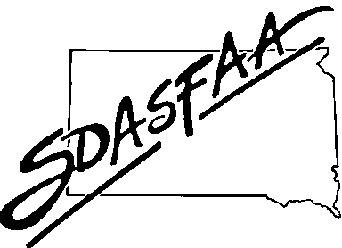
SDASFAA EXECUTIVE COUNCIL MEETING AGENDA
Wednesday, August 6, 2025 – 10am Central Time
Conference Call
Executive Council Members
Tracey Buisker (SDSU) President
Tirzah Knight (BHSU) President-Elect
Sydney Chapman (SDSU) Past President
Kim Nida (SDSMT) Secretary
Morgan Stadler (NSU) Treasurer
Stephen Detlefs (BHSU) Members at Large through 2025
Mary Alexandar (DWU) and Mindy Haerer (NAU) Members at Large through 2026
Sara Edwards (Citizens Bank) Associate Member at Large
Absent – Mindy Haerer (NAU)

- Call Meeting to Order 10:04 CT
- Approval of Agenda and Consent Agenda – motion by Morgan, second by Stephen – all aye
  - Past-President Sydney Chapman
  - President-Elect Tirzah Knight
  - President Tracey Buisker

- Approval of April 29, 2025 Executive Council Meeting Minutes – motion by Tirzah, second by Mary – all aye
- Officer Report
  - Treasurer Morgan Stadler
Spring conference final – income from last year’s HSCW included – CDs will mature this fall so will email board regarding how to proceed – discussion on spring conference registration fee-should we increase when we have such a large reserve? Morgan has only moved funds once to help cover expenses. What should we keep in reserve? Sara-other associations have 2-3 years in reserves. Tracey will reach out to other RMASFAA state delegates.
- Old Business
a. Board Welcome Packets ………………….Sydney Chapman
no update
b. Spring 2026 Conference with NE…………………………………………………………………………Tracey Buisker
NE has booked site for next several years – can continue to discuss if this is an option in a few years –
concerns include travel/office budgets for SD, sponsorship funds if we don’t host a conference – Sara thinks sponsorship funds not as much of an issue due to both states being there but may not have as many attendees
c. Committee Start Date………………………………………………………………………………………Tracey Buisker
new board starts at spring conference, not January 1 – Utah does this and it works well – election timeframe
would stay the same for travel to trainings/conferences – Tracey, Sydney, & Tirzah will discuss then go to a vote,
current board would stay on until spring conference – when spring conference ends, next board takes over

- New Business
a. Quick Books………………………..………………………………………………………………………...Tracey Buisker
ease of reporting and no reliance on spreadsheets – approximately $38 per month – morgan-questions about
historical data, login (use general email, not person/university) – Stephen-intuit has education so Tracey will check into it -
https://www.intuit.com/solutions/education/resources/quickbooks-support/educator-registration-form/
b. Committee/Board Start Date………………………………………………………………………………..Tracey Buisker
see above
c. Review Membership Dues………………………………………………………………………………….Morgan Stadler
we should be revisiting this topic each year - only recent change was adding fall sponsorship option – tracey-
sponsorship looks good for now, possibly increase by $25 to $100 but money in reserves needs to be taken
into consideration – sara-could/should we increase scholarship opportunities with reserve funds? 4 SDASFAA
members will attend RMASFAA this fall for LP – will revisit this topic in the future

- Committee Activity from Liaisons (see reports below)
a. Training Committee Kim Nida
new liaison for spring conference committee with the departure of Sydney Berens from SDSU – Carissa
Koerner will take her place – thank you, Carissa!
b. Communication/Website Kim Nida
c. Membership and Records Tirzah Knight
d. 2026 Spring Conference Tracey Buisker
e. 2025 Fall Training Stephen Detlefs
f. Review Committee Sara Edwards
how do LP mentees know what is covered by SDASFAA – RMASFAA state delegate (SDASFAA president) and
treasurer will work together to determine participants and payment of conference fee
g. election…………………………………………………………………………………………………….Sydney Chapman still in need of president-elect – other positions (secretary, treasurer, 2 members at large) will run unopposed

- Announcements
- RMASFAA 2025 Annual Conference: October 5-8, 2025, Wichita, KS
- SDASFAA Fall Training: November 18-19, 2025 – Arrowhead - Oacoma
- SDASFAA Spring Conference April: 28–30, 2026 – The Lodge in Deadwood

- Adjourn – motion by Sydney, second by Mary

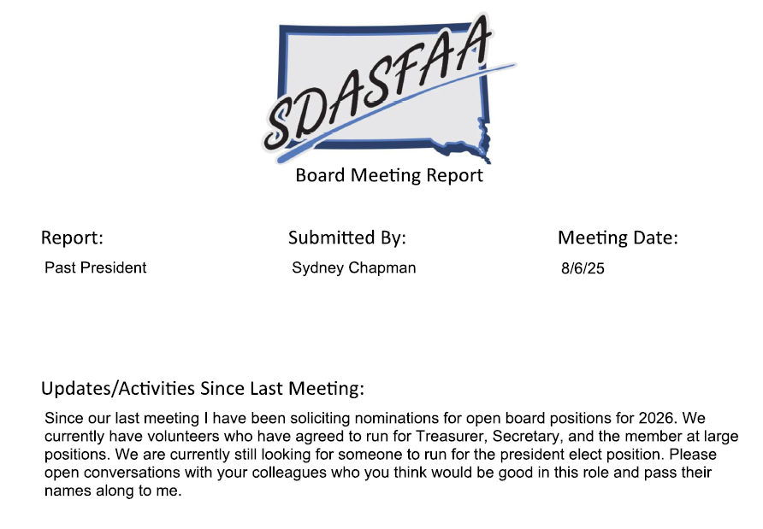

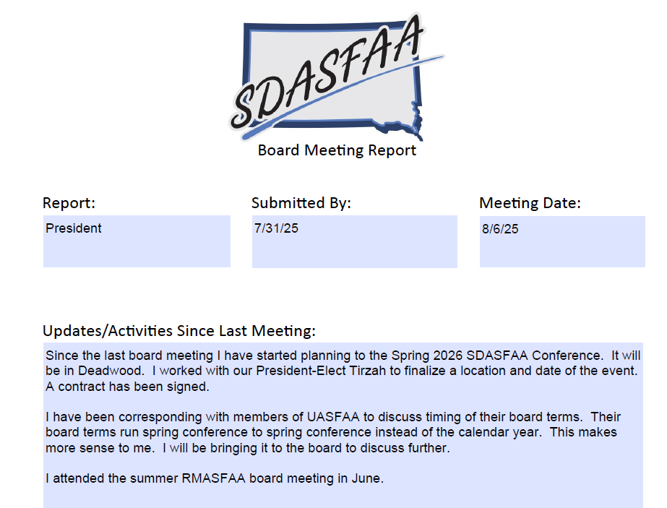

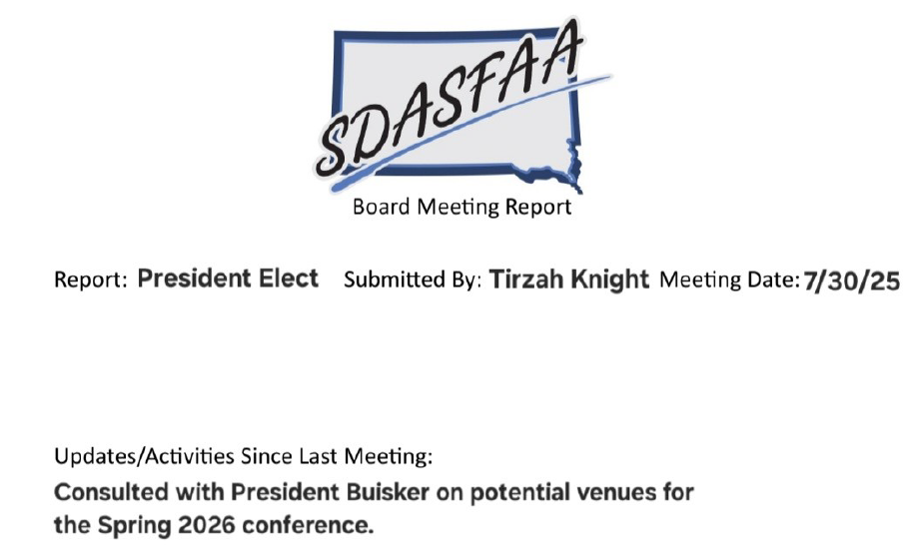

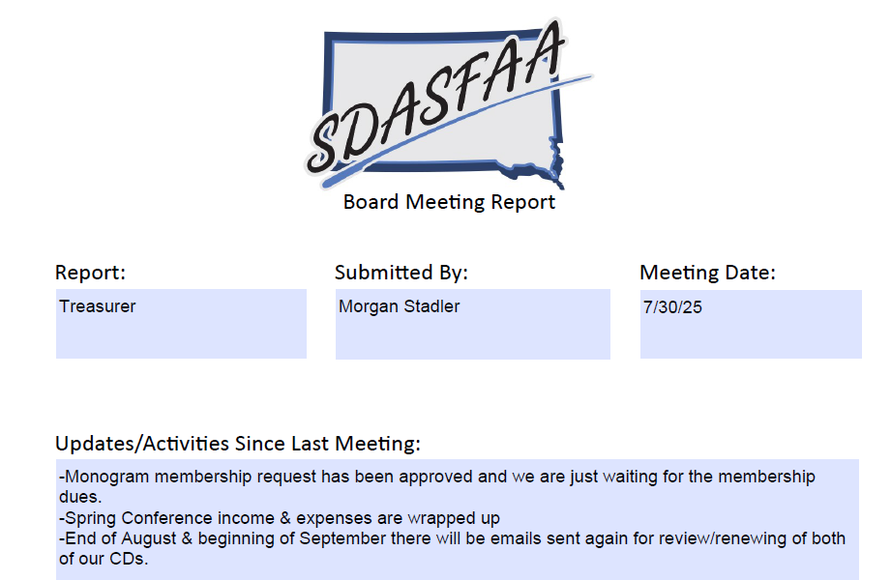
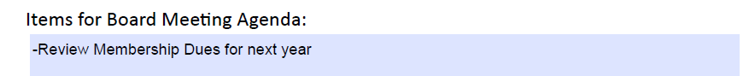

SDASFAA
Asset Statement
January 1, 2025-July 28, 2025
 |  |  | Savings -- Balance Sheet
Beginning Balance |  |  |  |  |  | $ 21,187.26
Interest Income |  |  |  |  |  | $ 5.25
Transferred from checkings to savings
Transferred from CD to savings
Transferred to new CD
Transferred from savings to checking |  |  |  |  |  | $ -
Ending Balance |  |  |  |  |  | $ 21,192.51
(personal savings acct, no fees, 0.05% interest, $300 min. bal.)
 |  |  | CD's -- Balance Sheet
CD ending 3037 - US Bank 5 Month
Beginning Balance |  |  |  |  |  | $ 17,674.80
Interest Income |  |  |  |  |  | $ 346.92
Transferred to savings
Ending Balance |  |  |  |  |  | $ 18,021.72
(renewed 3/31/2025, 5 months at 4%; Matures 8/31/2025)
CD ending 4018 - US Bank 5 Month
Beginning Balance |  |  |  |  |  | $ 28,031.76
Interest Income |  |  |  |  |  | $ 645.52
Transfer from savings
Ending Balance |  |  |  |  |  | $ 28,677.28
(renewed 4/8/2025, matures 9/8/2025, 5 months, 4%)
 |  |  | Balance Sheet Summary
Checking Account |  |  |  |  |  | $ 2,752.35
Savings Account |  |  |  |  |  | $ 21,192.51
CD - US Bank- 59 Months CD ending 3037 |  |  |  |  |  | $ 18,021.72
CD - US Bank 17 Month CD ending 4018 |  |  |  |  |  | $ 28,677.28
Total Available Assets |  |  |  |  |  | $ 70,643.86

SDASFAA
Financial Statement
January 1, 2025-July 28, 2025
BEGINNING BALANCE
 | Checking |  |  |  | 3,810.47
INCOME
 | Membership Dues |  |  | 2,625.00
 | Sponsorship Income |  |  | 4,300.00
 | Workshop Income |  |  | 5,835.00
 |  | Spring Conference | 5,775.00
 |  | Fall Training | 0.00
 |  | High School Counselor Workshop | 60.00
 | Miscellaneous Income |  |  | 0.00
TOTAL INCOME |  |  |  |  | 12,760.00
EXPENSES
 | Workshops |  |  | 9,058.80
 |  | Spring Conference | 9,058.80
 |  | Support Staff Workshop
 |  | Fall Training | 0.00
 | Executive Board |  |  | 0.00
 | Travel |  |  | 3,220.42
 |  | NASFAA Leadership Conference | 3,220.42
 |  | RMASFAA Board Meeting | 0.00
 |  | RMASFAA Conference | 0.00
 | Education Activities |  |  | 1,431.00
 |  | Membership and Records Committee | 0.00
 |  | Training Committee | 800.00
 |  | Recognition Committee | 631.00
 |  | Communication and Website Committee | 0.00
 | PayPal Expense |  |  | 97.90
 | Miscellaneous Expenses |  |  | 10.00
TOTAL EXPENSES |  |  |  |  | 13,818.12
TOTAL TRANSFERS |  |  |  |  | 0.00
 | Savings |  |  | 0.00
 | CD's
ENDING BALANCE -- Checking |  |  |  |  | $2,752.35

