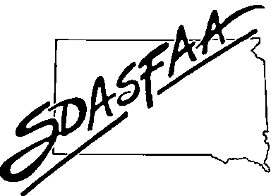
SDASFAA EXECUTIVE COUNCIL MEETING AGENDA
Tuesday, April 28, 2026 – 10 am MST/11 am CST
In person/via Zoom

Executive Council Members
Tirzah Knight (BHSU) President
Kim Nida (SDSMT) President-Elect
Tracey Buisker (SDSU) Past President
Sydney Chapman (SDSU) Secretary
Shyan Smith (SDSU) Treasurer
Mary Alexandar (DWU) and Mindy Haerer (NAU) Members at Large through 2026
Stephanie Frank (SDSU) and Carissa Koerner (USF) Members at Large through 2027
Sara Edwards (Citizens Bank) Associate Member at Large

Everyone is present except for Sara. Mary and Carissa are attending virtually.

Call to order at 10:01 MT.

- Call Meeting to Order
- Approval of Agenda and Consent Agenda
  - Past-President Tracey Buisker
  - President-Elect Kim Nida
  - President Tirzah Knight
No corrections discussed. Tracey motions to approve, Mindy seconds. Motion carries.

- Approval of February 19, 2026 Executive Council Meeting Minutes
No corrections discussed. No vote necessary

- Officer Report
  - Treasurer Shyan Smith
See report attached
  - Associate Member Sara Edwards
See report attached

- Old Business

- New Business
- Google Drive – Shyan Smith
Since we created a Gmail account, we now have access to google drive. Wondering if we want to convert things into a shared drive. Treasurer documents are currently stored on the USB flash drive. It would be nice to have the google drive as a
Discussion that board likes the idea. We think there could be concern with the security of a USB. This could also provide us with opportunities to move stored documents into one central location. Gives opportunity to make things available to everyone necessary and provide a place to store historical documents.

- Membership boxes – Morgan Stadler/Tirzah Knight
We have several boxes with various items that we can sort or get rid of and consolidate. We will plan to have several of us work through.

- Consolidation/reduction of board positions and committees

- Committee Activity from Liaisons
a. Training Committee Carissa Korener
Cathy Mueller sent a report. Carissa is the reporter for future board meetings. See attached report.
b. Communication/Website Sydney Chapman
See attached report. Kim has been training for being a backup for the website. Could we have some procedures created so that others can assist if needed? Can we have multiple people with access to edit the website? Maybe we need to have the whole communications/web committee get access and have procedures to demonstrate what is necessary to make updates then as we move along with that model we will grow a group of people with knowledge on making website updates.
c. Membership and Records Tirzah Knight
See attached.
d. 2026 Spring Conference Tracey Buisker
See attached.
f. Review Committee Sara Edwards
See attached.

- Announcements
- SDASFAA Spring Conference – April 28-30, 2026 – Deadwood
- NASFAA National Conference – June 29-July 2, 2026 – National Harbor, MD
- RMASFAA Fall Conference – October 11-14, 2026 – Fargo, ND

- Adjourn

Sydney motions to adjourn. Kim seconds. All aye, motion passes. Meeting adjourned at 11:33am MT.

